Departmental lab IV (Assignment VI)
CS 418 ( Digital Image Processing and Computer Vision)
Problem 1.

(a) Load brain.png from the example images. This is a vertical cut (called sagittal in medicine) though the head. The ventricle is the dark region in the middle of the image. Find a threshold to segment the ventricle; of course, the background etc will be detected as well. Show the thresholded image.
(b) Implement the region growing algorithm we discussed in class. Use the location (132, 76) as the seed point, apply region growing to your thresholded image to segment the ventricle alone.
(c) Add Gaussian noise to the image using the command Inoisy = I+20*randn(256). Does region growing still work successfully by itself? Find a modified solution that gets an approximate segmentation.

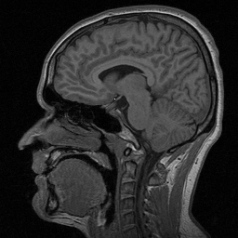

Figure 3: Brain.png

Code
i=imread('brain.png');
subplot(2,3,1);imshow(i,[]);title('Original Image');
l=graythresh(i);
i=im2bw(i,l);
subplot(2,3,2);imshow(i,[]);title('Thresholded Image');
S=zeros(size(i));
S(132,76)=255;
[g,p,q,r]=regiongrow(i,S,0.1);
subplot(2,3,3);imshow(g,[]);title('After region growing');

[M N]=size(i);
R=imnoise2('gaussian',M,N,0.05,0.05);
B=im2double(i);
F=B+R;
subplot(2,3,4),imshow(F,[]);title('Noisy Image');

i=medfilt2(i);
subplot(2,3,5);imshow(i,[]);title('Restored Image');
[g,p,q,r]=regiongrow(i,S,0.1);
subplot(2,3,6);imshow(g,[]);title('Region growing on restored image');

function [g,NR,SI,TI]=regiongrow(f,S,T)
f=double(f);
if(numel(S)==1)
SI=f==S;
S1=S;
else
SI=bwmorph(S,'shrink',Inf);
J=find(SI);
S1=f(J);
end
TI=false(size(f));
for(K=1:length(S1))
seedvalue=S1(K);
S=abs(f-seedvalue)<=T;
TI=TI|S;
end
[g,NR]=bwlabel(imreconstruct(SI,TI));

function [ R ] = imnoise2( type, M,N,a,b )
if nargin ==1
a=0; b=1;
M=1;N=1;
elseif nargin==3
a=0;b=1;
end

switch lower(type)
case 'uniform'
R=a+(b-a)*randn(M,N);
case 'gaussian'
R=a+b*randn(M,N);
case 'rayleigh'
R=a+(-b*log(1-rand(M,N))).^0.5;
case 'exponential'
if nargin<=3
a=1;
end
if a<=0
error('Parameter a must be positive dor exponential type.');
end
k=-1/a;
R=k*log(1-rand(M,N));
case 'erlang'
if nargin<=3
a=2;b=5;
end
k=-1/a;
R=zeros(M,N);
for j=1:b
R=R+k*log(a-rand(M,N));
end
otherwise
error('Unkown distribution type');
end

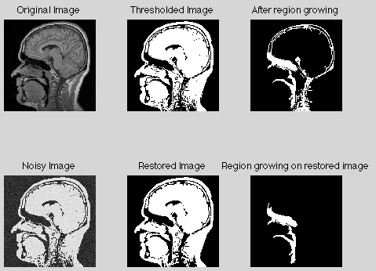
Image 1 : original image
Image 2 : threshold image
Image 3 : region detcted image
Image 4 : original image with noise
Image 5 : threshold image
Image 6 :region detcted image
Because of introduction of noise extra portion is detected in the output even when it is not supposed to be. Some of the needed area is now not being shown in the output because of the noise.
Problem 2.

(a) Download SegmentationImage.png (shown in figure 2). The first goal is to segment the square object. Global thresholding will not work because of illumination changes. Implement the following adaptive thresholding algorithm:
1. Divide the image into 32 x 32 blocks.
2. For each block decide if one or two regions are present by computing the variance of intensities
in that block and comparing it to a threshold ( you can choose the threshold by experimenting upon different samples)
Display your results.
(b) Can you improve your results by smoothing the image before segmentation?

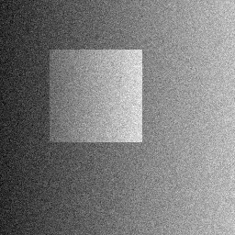
Figure 2: segmentationImage.png
Code
i = imread('SegmentationImage.png');
figure(1)
subplot(2,2,1),imshow(i);title('Original Image');
subplot(2,2,2),imhist(i);title('Histogram of the Image');

for x=1:64
for y=1:64
if i(x,y) <=105
i(x,y)=0;
else
i(x,y)=255;
end
end
end
%figure(2)
%imshow(i)
for x=1:64
for y=65:128
if i(x,y) <=120
i(x,y)=0;
else
i(x,y)=255;
end
end
end
%figure(3)
%imshow(i);
for x=1:64
for y=129:196
if i(x,y) <=180
i(x,y)=0;
else
i(x,y)=255;
end
end
end
%figure(4)
%imshow(i);
for x=1:64
for y=197:256
if i(x,y) <=1200
i(x,y)=0;
else
i(x,y)=255;
end
end
end
%figure(5)
%imshow(i);
for x=65:128

for y=1:64
if i(x,y) <=105
i(x,y)=0;
else
i(x,y)=255;
end
end
end
%figure(7)
%imshow(i)
for x=65:128
for y=65:128
if i(x,y) <=120

i(x,y)=0;
else
i(x,y)=255;
end
end
end
%figure(8)
%imshow(i);
for x=65:128
for y=129:196
if i(x,y) <=180

i(x,y)=0;
else
i(x,y)=255;
end
end
end
for x=65:128
for y=197:256
if i(x,y) <=1200

i(x,y)=0;
else
i(x,y)=255;
end
end
end
for x=129:196

for y=1:64
if i(x,y) <=105
i(x,y)=0;
else
i(x,y)=255;
end
end
end
%figure(7)
%imshow(i)
for x=129:196
for y=65:128
if i(x,y) <=120

i(x,y)=0;
else
i(x,y)=255;
end
end
end
%figure(8)
%imshow(i);
for x=129:196
for y=129:196
if i(x,y) <=180

i(x,y)=0;
else
i(x,y)=255;
end
end
end
for x=129:196
for y=197:256
if i(x,y) <=1200

i(x,y)=0;
else
i(x,y)=255;
end
end
end
for x=197:256
for y=1:256
i(x,y)=0;
end
end
%figure(9)
subplot(2,2,3),imshow(i);

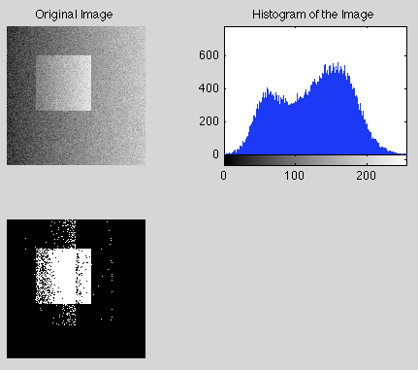

By adding these two lines before the code we remove the noise
mask = fspecial('average');
i=imfilter(i,mask);
Output after removing the noise is:

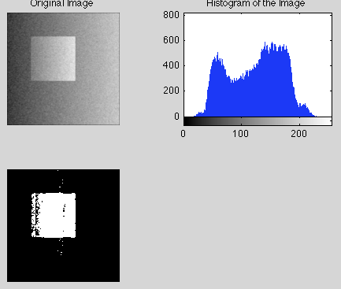

Problem 3.

A company that bottles a variety of industrial chemicals has heard of your success solving imaging problems and hires you to design an approach for detecting when bottles are not full. The bottles appear as shown in the figure as they move along a conveyor line past an automatic filling and capping station. A bottle is considered imperfectly filled when the level of liquid is below the midway point between the bottom of the neck and the shoulder of the bottle. The shoulder is defined as the region of the bottle where the sides and slanted portions of the bottle intersect. The bottles are moving, but the company has an imaging system equipped with an illumination flash front end that effectively stops motion, so you will be given the images that are very close to the samples shown here in figure 3. Based upon the material you have learned upto this point, propose a solution for detecting the bottles that are not filled properly. State clearly all the assumptions you make and that are likely to impact the solution you propose.

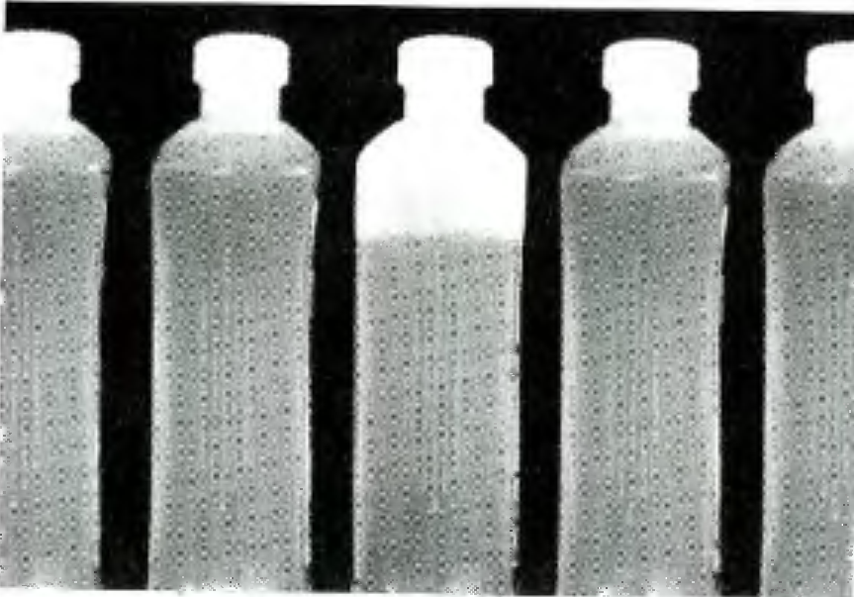
Figure 3: Sample Bottles
a=imread('bottles.tif');
i = imread('bottles.tif');
img = i;
filled_pixel = i(200,170);
[m n]= size(i);
for j=1:m
for k=1:n
if (i(j,k)-filled_pixel)>60
i(j,k)=255;
else
i(j,k)=0;
end
end
end
figure(1)
imshow(i);title('Binary Image to show the contents of the Bottle');
x = 78;
flag=0;
for w=220:290
if i(x,w)~=255;
flag=1;
end
end
error = 'bottles.tif';
if flag==0
figure(4)
imshow(error);title('Bottle not filled compeletly:Error');
end
figure(2);
subplot(2,2,1), imshow(img);
subplot(2,2,2), imhist(img);
subplot(2,2,3), imshow(i);
subplot(2,2,4), imhist(i);

Output:
